Free + Pro Subscription Model
Commercial proposal | Student journeys | Annual cost allocation
Decision requested: approve a two-plan launch with Pro priced at ₹179/month or ₹1,499/year, subject to validating actual cost per active student. These are proposed selling prices, not approved rates.

01 Model at a glance
FREE | PRO MONTHLY | PRO YEARLY
₹0 | ₹179 | ₹1,499
Ongoing exploratory access | 30-day paid access | 12-month paid access
Free-eligible modules and limited trials | Pro-eligible catalog within usage caps | Same monthly caps refreshed during annual term
No payment required | Manual purchase / renewal | Manual purchase / renewal

Scope of learning
PROGRAMS | MODULES
Virtual Internship Program (VIP) | Courses
Ready for Class | Projects / Capstones
Mind Role | Labs
Pass | Certificate Preparation
 | Assessments

Program naming should be confirmed before student-facing publication. Access to live delivery, human evaluations, external certificates, or institution-funded activities is excluded unless separately approved.

Guiding product decisions
• Free remains available before and after a Pro subscription. Learning history and progress stay saved.
• Pro enables eligible content, not unlimited high-cost usage: enrollment slots and AI/compute budgets are both enforced.
• No automatic debit is assumed at launch. Student selects and pays for each renewal manually; any future auto-pay choice requires a supported payment mandate.
• University-assigned learning remains separate from a student’s personal paid subscription.
• Plan changes apply to new purchases; existing purchases retain their agreed entitlements until their term ends.

02 Proposed feature allowances
These are controlled launch assumptions designed for cost testing—not final product promises. “Active” means concurrently enrolled; usage refreshes monthly for both billing durations.
ENTITLEMENT | FREE | PRO — PROPOSED CAP
Courses | Free catalog / preview | 1 new course enrollment each month; max 2 active
Labs | Demo only | 2 standard lab sessions / month
Projects | Preview | 1 automated project evaluation / quarter
Certificate Prep | Preview | 1 active track; metered practice
Assessments | Limited sample practice | 2 assessed attempts / month
Virtual Internship Program | Browse / preview | Selected self-paced VIP pathway; no live mentorship included
Ready for Class | Browse / preview | Selected digital modules; delivery costs separately reviewed
Mind Role | Browse / preview | Selected digital pathway; expensive services gated
Pass | Browse / preview | Selected digital pathway; exam/credential fees not bundled
AI use | Small one-time trial if approved | Shared budget measured by rupee cost; example cap 25 product tokens/month only after calibration

Bundled-content rule proposed: selecting a program should not separately consume module enrollment slots for its built-in components, but all AI, compute, and evaluation usage must still count toward the metered budget. Confirm before development.

Rules students must understand
• Selections normally cannot be swapped during an active period; completed enrollments still occupy active slots until the relevant renewal/reset.
• At renewal students can retain, replace, or combine eligible selections within available new-term slots.
• When paid access expires, Pro-only content locks; prior learning records remain visible.
• No 7-day payment grace period under the latest reference decision: service resumes after successful manual renewal.
• If content is withdrawn or broken by SkillWallet, the platform should provide a remediation exception rather than permanently wasting a paid slot.

03 Student subscription journeys
Four core journeys; consistent milestones and outcomes for quick discussion.
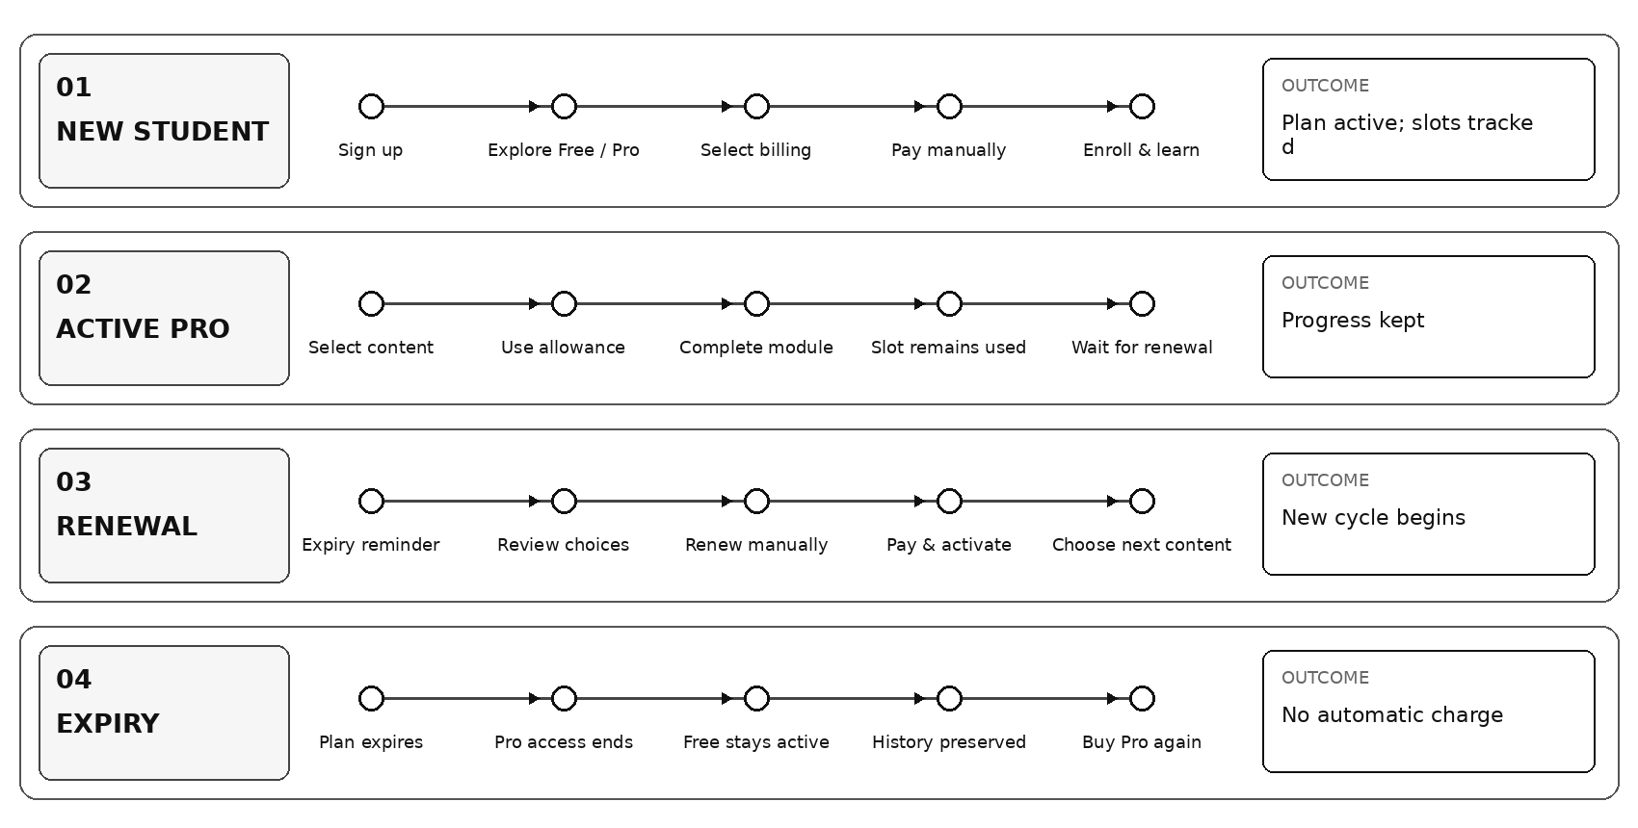

Important exception flows
CASE | SYSTEM BEHAVIOR
Student purchases Pro during Free | Activate Pro after successful manual payment; show limits, validity and selected content.
Student finishes a course early | Completion does not create an extra enrollment slot in the current term.
Student runs out of AI allowance | Pause metered AI actions or offer an approved top-up; preserve learning access.
Student changes Monthly ↔ Yearly | New purchase activates according to a disclosed effective-date rule; no automatic charge.
Student misses renewal | Paid entitlements end on expiry; Free access and progress continue.
Content becomes unavailable | Escalate for replacement/remediation; no silent deletion of progress.

04 ₹1,499 annual price: proposed allocation
For comparison, ₹1,499 is treated as GST-inclusive at an illustrative 18% rate. Actual tax and fee treatment must be confirmed by Finance.
ANNUAL REVENUE BRIDGE | PER STUDENT
Paid by student | ₹1,499.00
Illustrative included GST (₹1,499 × 18/118) | ₹228.66
Net revenue before operating costs | ₹1,270.34

Draft annual servicing budget per paying student
COST CATEGORY | ANNUAL BUDGET
AI / Zaby interactions | ₹240
Infrastructure + standard labs | ₹180
Digital content creation / licensing | ₹120
Automated evaluations | ₹120
Student support | ₹90
Payment handling | ₹35
Student acquisition allocation | ₹110
Engineering + administration allocation | ₹140
Refund / abnormal usage reserve | ₹80
Total planned cost | ₹1,115
Remaining contribution | ₹155.34
Contribution margin on ex-tax revenue | 12.2%

Interpretation: this is an illustrative maximum-spend framework, not proof of profitability. A 20% contribution margin would require all-in costs of no more than approximately ₹1,016 per annual subscriber. The budget above leaves little room for unexpected manual evaluation or heavy AI usage.

What the supplied token sheet establishes
EXAMPLE ESTIMATE | SHEET VALUE
SME-created example bundle — average tokens | 1,785
Learner-created example bundle — average tokens | 2,941
SME-created bundle — estimated Zaby cost | ₹89.24
Learner-created bundle — estimated Zaby cost | ₹245.10

The sheet’s bundle outputs and cost columns are not fully reconciled and do not establish an annual cost/student. ₹240 for AI is a provisional allowance: one average learner-created example bundle alone is listed at approximately ₹245.10. Before fixing entitlements, validate token-to-rupee conversion, feature frequency, and who bears generation costs.

05 Viability checks and launch guardrails
SCENARIO | ANNUAL ALL-IN COST | REMAINING CONTRIBUTION
Efficient usage | ₹850 | ₹420.34 (33.1%)
Planned budget | ₹1,115 | ₹155.34 (12.2%)
Heavy usage | ₹1,350 | –₹79.66 (loss)

Monthly must be evaluated separately: ₹179 inclusive of illustrative 18% GST yields about ₹151.69 before servicing costs. Subscription price does not guarantee a margin if expensive feature usage concentrates in one month.

Minimum data collection before approval
OWNER | REQUIRED INPUT
Backend / AI | Real provider-billed ₹ per token, course-generation cost, CertPrep and AI interaction cost, 90th-percentile heavy-user pattern.
DevOps | Server, storage, video, lab execution, and monitoring costs at 100 / 1,000 / 10,000 active students.
Operations | Support cost, manual review/evaluation hours, paid-program delivery obligations.
Finance | GST treatment, gateway fees, refunds, marketing CAC, fixed cost allocation.
Product | Student enrollment forecasts, monthly vs yearly mix, conversion and retention, exact program inclusions.

Founder approvals
☐ Approve pricing test: Free ₹0, Pro ₹179 monthly, Pro ₹1,499 yearly.
☐ Approve initial module/program inclusion matrix and which expensive services remain excluded.
☐ Confirm whether monthly allowances refresh within yearly plans and whether “course enrollment” resets monthly.
☐ Approve AI/compute metering and a hard cost threshold per account.
☐ Confirm billing-cycle switch effective date and manual payment UX.
☐ Require a 100-student cost and conversion pilot before public launch.
Recommendation: approve the commercial direction now, but release price and promised limits only after the team reconciles AI unit costs and tests high-usage students. A viable launch can be broad in content and still disciplined in expensive service usage.

